**Qualities of a legitimate playlist:**

* **Regular updates**
* **Reasonable number of tracks per playlist**
* **Reasonable number of followers**
* **Must have a very gradual rate of change of followers**
* **Should not be flagged for any reason (Must not exist in ‘black list’)**
* **Playlist should have a name**

**Conditions that need to be satisfied for a playlist to be ‘legitimate’:**

* **Playlist exists on Spotify**
* **The last track upload should have happened within last 90 days**
* **Must have above 70 followers**
* **Smoothness score* must be above 0.0009**
* **Playlist is not blacklisted**
* **Playlist name exists**

**Example of a legitimate Playlist:**

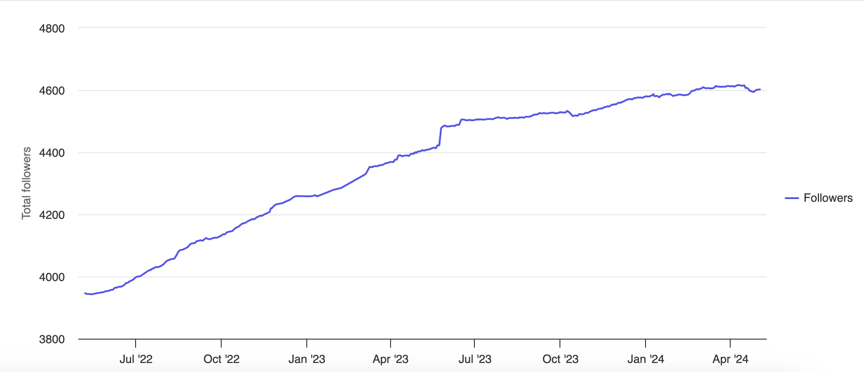

**Example of a Botted Playlist:**

